**Special Session of ICACI2023**

**Open-set Learning and Diagnostics**

**Session Organizers:**

● Dr. Weidong JIAO, Zhejiang Normal University, China; Email: jiaowd1970@126.com

● Dr. Attiq Ur REHMAN, Zhejiang Normal University, China; Email: atnutkani@gmail.com

● Dr. Anping WAN, Zhejiang University City College, China; Email: wanap@zucc.edu.cn

● Dr. Jianan WEI, Guizhou University, China; Email: [jawei@gzu.edu.cn](mailto:jawei@gzu.edu.cn)

● Dr. Haisong HUANG,Guizhou University, China; Email: hshuang@gzu.edu.cn

**Session Description:**

Machine-learned recognition/diagnosis models have shown promise in every application. Traditional supervised learning aims to train a classifier in the closed-set world, where training and test samples share the same label space. However, in a real-world application, it is very difficult to classify accurately where it needs to deal with unknown classes. A more realistic scenario is open-set classification or open-set recognition. This requires the classifiers to not only accurately classify the known classes but also effectively deal with unknown ones that were not anticipated during the training phase. This special session is organized to focus on the recent development of open-set learning and diagnostics.

**Potential topics include but are not limited to the following:**

■ Open-set fault diagnosis approach for machinery components

■ Intelligent fault diagnosis based on deep/transfer learning and big data

■ Open-set medical diagnosis

■ Intelligent fault diagnosis models and algorithms (e.g., imbalanced learning, few-shot learning, positive-unlabeled (PU) learning, zero-shot learning, and modeling methods under various operating conditions).

■ Other advances in fault diagnosis/prognosis and life prediction based on deep learning algorithms

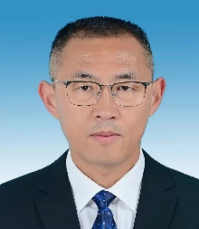**Dr. Weidong Jiao** was born in Wafangdian, Liaoning, China, in 1970. He received the B.E.

and M.E. degree in safety engineering and mechanical engineering from Gansu University of Technology, Lanzhou, in 1992 and 2001, respectively, and the Ph.D. degree in mechanical engineering from Zhejiang University, Hangzhou, in 2004. Since 2013, he serves as a Professor with the School of Engineering, Zhejiang Normal University, Jinhua. His research interests include smart test and signal processing, mechanical dynamics, condition monitoring, and fault diagnosis of mechanical equipment.

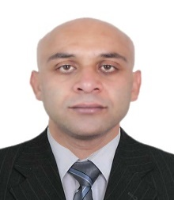**Attiq Ur Rehman** was born in Punjab, Pakistan, in 1988. He received the B.S. degree in electronics engineering in 2010, from COMSATS Institute of Technology, Abbottabad, Pakistan, and the M.S. and Ph.D. degrees in electrical engineering from Xi’an Jiaotong Univercity, Xi’an, China, in 2015 and 2020. Currently he serves as a postdoctroral researcher with Zhejiang Normal University. His special fields of research interests include condition monitoring and fault diagnosis/prognosis of electrical and mechanical equipments.

**Dr. 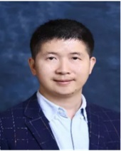Anping Wan** was born in Nanchang, Jiangxi, China, in 1983. He received the B.E. degree in traffific equipment information engineering from Central South University, Changsha, China, in 2007, the M.S. degree in thermal engineering from Zhejiang University, Hangzhou, China, in 2010, and the Ph.D. degree in thermal engineering from Zhejiang University, Hangzhou, China, in 2014. He used to work as a Post-Doctoral Fellow at the Institute of Mechanical Manufacturing and Automation, Mechanical Engineering College, Zhejiang University, from 2014 to 2016, and Post-Doctoral Fellow at the Computer Science and Technology Institute, Mechanical Engineering College, Zhejiang University, from 2016 to 2019. He is currently a associate professor with Zhejiang University City College, Hangzhou, China. He has broad interests in mechanical and energy engineering with a special interest of fault diagnosis and health management of mechanical equipment.

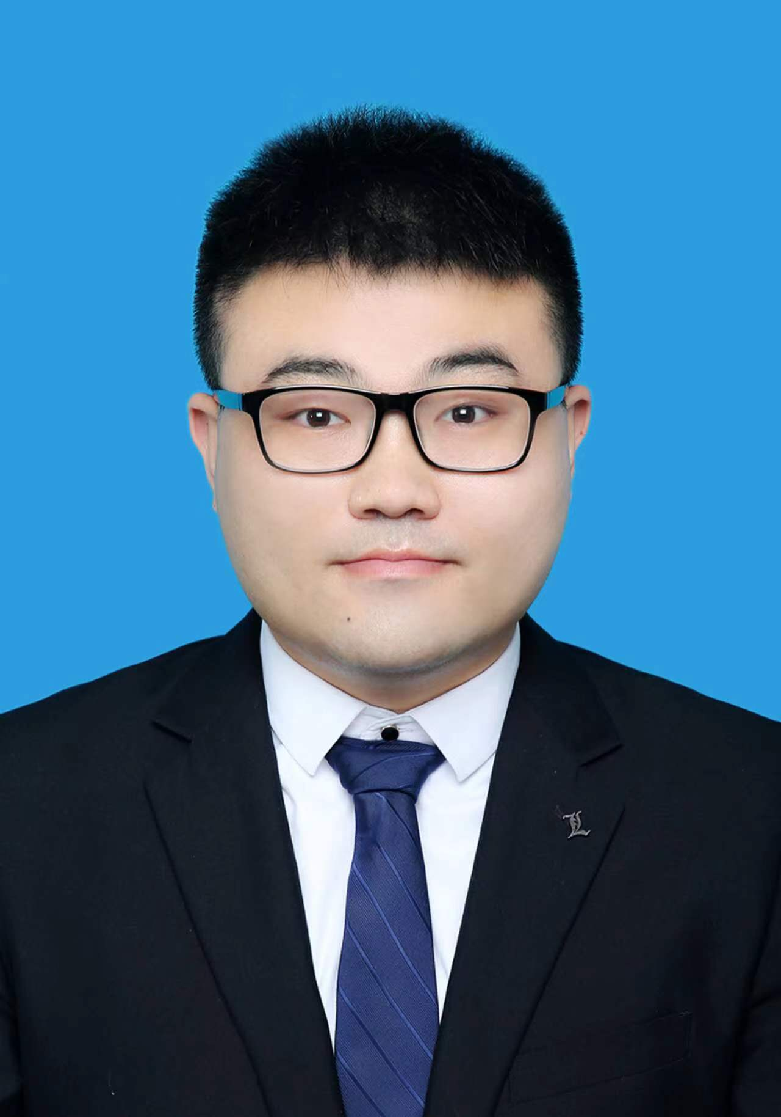**Dr. Jianan Wei** was born in Chaoyang, Liaoning, China, in 1992. He received the B.E. degree from Shenyang Institute of Engineering(SIE), Shenyang, China, in 2015, and the M.E. and the Ph.D. degree from Guizhou University, Guiyang, China, in 2018 and 2021, respectively. Since 2022, he serves as a School-appointed Professor in Key Laboratory of Advanced Manufacturing Technology, Ministry of Education, Guizhou University. His research interests include manufacturing big data and manufacturing information systems, intelligent manufacturing, machine learning, deep transfer learning, fault diagnosis, imbalanced data processing and predictive maintenance.

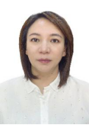**Dr. Haisong Huang** was born in Bijie, Guizhou, China, in 1977. She received the B.E. degree from Hohai University, Changzhou, China, in 1999, the M.E. degree from Chongqing University, Chongqing, China, in 2004, and the Ph.D. degree from Guizhou University, Guiyang, China, in 2012. Since 2015, she serves as a Professor in Key Laboratory of Advanced Manufacturing Technology, Ministry of Education, Guizhou University. Her research interests include manufacturing big data and manufacturing information systems, intelligent manufacturing.